**Neo-sex chromosome shapes introgression in a hybrid swarm**

Silu Wang1, Matt J. Nalley1, Kamalakar Chatla1, Russ Corbett2, Doris Bachtrog1

1Integrative Biology

University of California, Berkeley

3040 VLSB, Berkeley, CA, USA 94720

2Biomolecular Engineering and Genomics Institute

University of California, Santa Crutz

Corresponding author email: dbachtrog@berkeley.edu

**Introduction**

Speciation is the fundamental process that generates the diversity of life (Darwin 1859). The core genetic mechanism underlying speciation is genomic evolution preventing introgression between divergent lineages (Campbell et al. 2018). Inheritance processes delineates the extent of introgression at species boundaries (polyploidy, inversion, cite the toad paper, ploidy change, etc.). It is the most simple intrinsic genetic mechanism of reproductive isolation, yet we still know very little.

Hybrid swarms, the multi-generational laboratory hybrid population generated by interbreeding diverged lineages, are ideal to investigate genomic barriers to introgression. Hybrid swarms experience recombination over multiple generations and thus harbor a variety of genomic combinations, allow time-series tracking of genomic dynamics, and reflect the extent and direction of gene flow at different regions in the genome.

**-**selection again hybrids would be more evident in later generation hybrids

**-**Increase in LD among barrier loci over generations of hybrid swarm

*Drosophila albomicans* is an interesting to evaluate the role of neosex chromosomes in reproductive isolation. [background of muller CD and A fusion, geography, closely related species, divergence time]

Here we generated hybrid swarms of *D. albomicans* (abbreviated as alb hereon) and its sister taxon, *D. nasuta* (abbreviated as nas hereon) which harbors extensive genomic differences and sequenced the random samples from the hybrid swarm for 28 generations to investigate the effect of neosex chromosome on gene flow.

We investigate how are ancestry blocks get or not get broken down by hybridization. In particular, we look for candidate barrier genomic modules.

**Methods**

*Hybrid swarm*

N= of each sex of each species were crossed

Plexiglass (dimension), the arena is maintained at room temperature, humidity, light-dark cycle.

Reference haplotypes

*Sequencing*

We sequenced at early generation (0-5, N=21), generation 10 (N=1), generation 18 (2), 21 (N=22), 27 (N=44), and 28 (N=37).

*Sequence processing*

We aligned the reads to a *sulfurigaster* reference with bwa (Li 2010). Trim the reads, read quality cutoff =20. Individuals with less than 50,000 reads were excluded from downstream analysis.

*Ancestry calling*

Ancestry HMM was used to infer local genomic ancestry among hybrids in the hybrid swarm experiment. Following setting was employed: *-a 2 0.5 0.5 -p 0 -3 0.5 -p 1 -3 0.5 -r 0.000005*. In particular, we assumed equal parental ancestry contributions, and recombination rate being 5X10-6, and estimated the generations before present in which the ancestry pulse occurred. Ancestry genotype was called if the posterior probability > 0.9.

We first find the fixed difference (SNP-based FST =1) between nasuta and albomicans. Then we prepared the input for ancestry HMM with a custom script. 0= nasuta, 0.5 = heterozygotes, 1 = albomicans.

*Neosex chromosome haplotyping*

Neo-X and Neo-Y specific alleles in albomicans were identified following Wei et al. (2019). The neo-sex chromosome SNPs should be hemizygous in males and homozygous in females, thus the ratio of coverage between female and male should be 2. For each individual, we estimated the haplotype proportion (proportion of sites of each haplotype across all the haplotype-informative sites). We refer the any single haplotype with > 0.5 haplotype proportion being the neosex chromosome ‘haplotype background’ of each individual. This way, we can association between neosex chromosome haplotypes with introgression and ancestry turnover rates.

*Introgression*

We considered introgression with respect to the extent of admixture inferred with heterozygosity. Heterozygosity (*h*) was calculated as the fraction of heterozygous ancestry-informative sites within each individual. Admixture proportion (*p*) was the fraction of alb alleles across ancestry-informative sites. We calculated admixture proportion and heterozygosity both genome-wide and within each Muller element. To investigate the introgression across various muller element, we calculated Muller element-specific alb-biased introgression as

$\frac{1-2p}{1-h}$.

This alb-biased introgression index ranges ranging from -1 (nas-biased introgression) and 1 (alb-biased introgression) with zero implying equal introgression from either ancestry. It controls for the fact that hybrids with more admixed genomes (lower heterozygosity, greater deviation of *y* from 1) and signature of backcrossing (positive deviation of *x* from 0.5) are more likely to demonstrate asymmetrical introgression.

*Ancestry turnover across the genome*

We estimated ancestry turnover rate (*r*) by the number of ancestry switches across each muller element and across the genome. However, hybrids of later generations of admixture will exhibit more recombination, while backcrosses exhibit less recombination. To ensure that each class of hybrids are comparable, we employed a transformation index based on the Euclidian distance between the position of each individual and the point (0.5, 0) in the triangle plot.

$$λ= \sqrt{{(x-0.5)}^{2}+y^{2}}$$

The greater the distance, the less recombination event is expected. Thus r $λ$* is the admixture-corrected recombination estimate.

To compare ancestry turnover frequency among different Muller elements, the per informative site ancestry turnover rate was used, by dividing the ancestry switches by the number of informative sites in each Muller element. Muller F is excluded from this comparison because of the scarcity of informative sites.

*Inter-chromosomal and long-range LD analysis*

To investigate the co-introgression pattern within and among chromosomes, we calculated r2 among clusters of sites that segregate independently. We clustered consecutive SNPs into haplotype clusters with K-means clustering with the 70% of total variance explained by between-clusters variance. Considering the paucity of SNPs and the lack of recombination in Muller F, we employed a lower threshold, 50% for clustering SNPs within Muller F. To execute K-means cluster, we first imputed missing genotype by the genotypic mode within 2Mb, and removed the individuals that still had missing genotypes after imputation, which resulted in 188 individuals (131 females and 51 males) remaining for downstream analysis. We than calculated LD among haplotype clusters within Muller CD and those in other Muller elements. We looked into associations among females sampled in early generations (generation 1-16) and later generations (generation 17-28).

*Genomic clines*

To detect potential genetic clusters that serve as barriers to gene flow, the pattern of introgression for each genetic cluster was inferred with genomics clines (Gompert and Buerkle 2011). We estimated cline parameters for each genetic cluster based on cluster-specific introgression relative to the genomic background. We focused on late generation (21, 27, 28) females, because the signature of selection tends to become more evident when the masking admixture effect becomes less pronounce after generations of recombination.

**Results**

*Asymetrical Introgression*

There was albomicans-biased genome-wide introgression, which was predominantly represented by Muller CD (Figure triangle plot; Figure BGC plot with muller cd haplotypes). Even though the genomes of many hybrids were admixed in the rest of the genome, muller CD is mostly dominated by the albomicans ancestry (Figure 1-3), which reveals albomicans-biased barrier effect of muller CD relative the rest of the genome (Figure 4A). The *α* and *β* estimates ± SE of muller CD cline is respectively 0.102 ± 0.056, 0.476 ± 0.169.

*Recombination associated with individual Muller CD haplotypes*

Genome-wide albomicans introgression is significantly associated with Muller CD haplotypes. There was significantly less recombination rate (Figure 4B) and greater albomicans-biased introgression (Figure 4C; p < 0.05) within Muller CD than other muller element. In particular, individuals of albomicans (neo-X, neo-X) and (neo-X, neo-Y) showed greater genome-wide albomicans introgression (*p* < 10-6 among females; Figure 4D), and they harbor more genome-wide ancestry turnovers than individuals with nasuta Muller CD (*p* < 0.05; figure 4E).

*Genomic clines*

In early generations, signatures of admixture swamps the footprints of selection which settles down in later generations. In later generations (21, 27, and 28), the inversion within Muller CD is repetitively exhibits signatures of selection against hybrids (positive beta values, and the 95% CIs don’t include zero) (Figure 5 BGC cluster).

*LD patterns* (Figure 5)

Only Muller A harbor clusters that are in significant LD with Muller CD sites in early generation females. However, in late generation, sites within Muller A, Muller B, Muller E, in addition to muller F became significantly in LD with Muller CD.

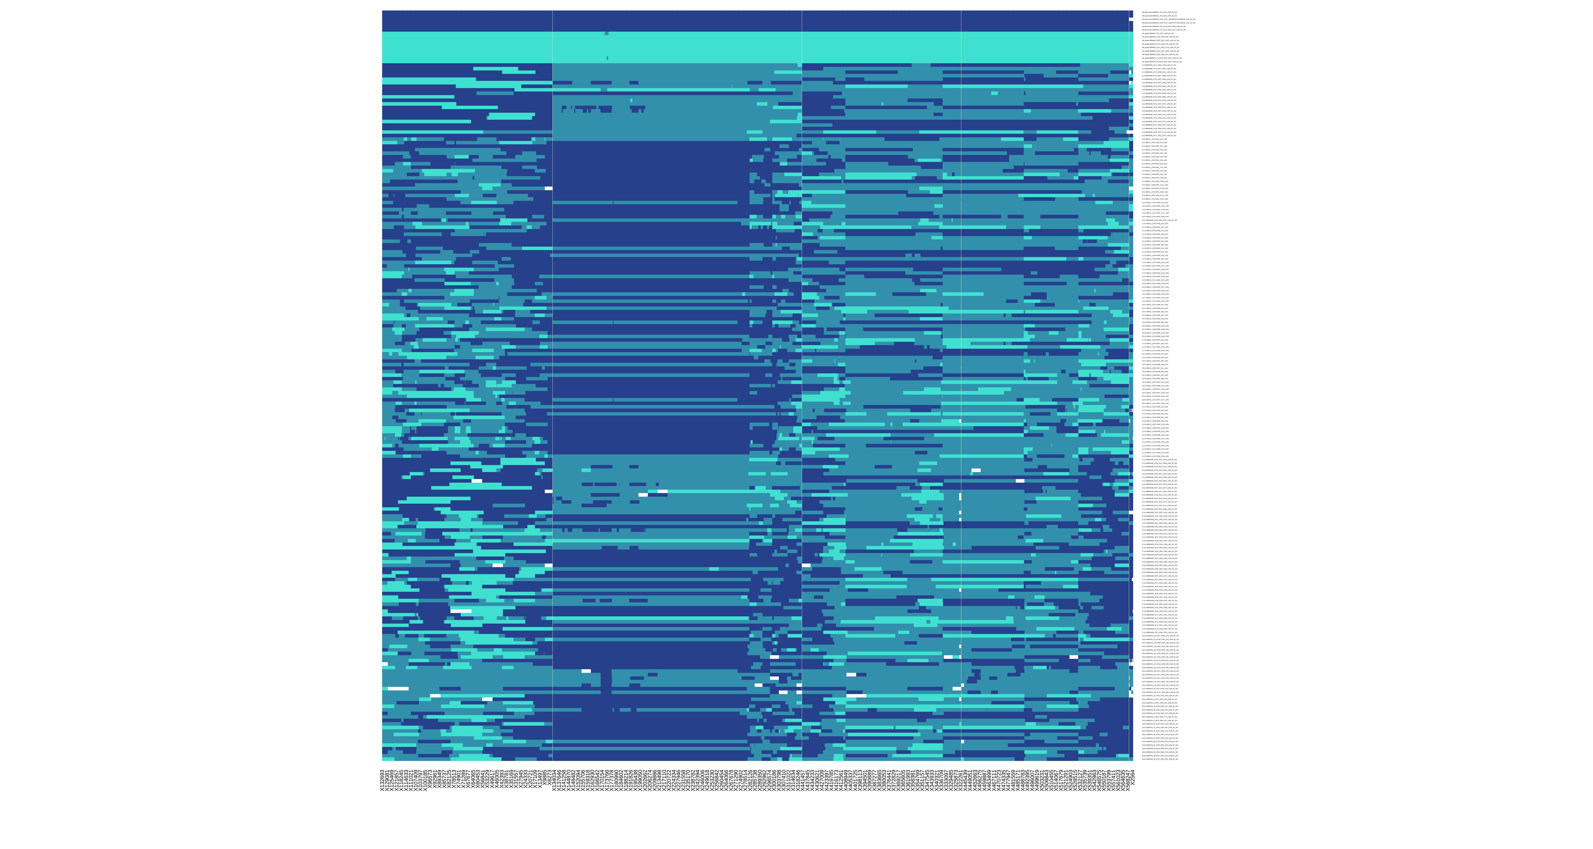

**Figure 1** Ancestry haplotypes (in columns) in hybrids of various generations (rows). The turquoise and royal blue respectively represents homozygous nasuta and albomicans genotype, and the heterozygous genotypes are represented by pale blue.

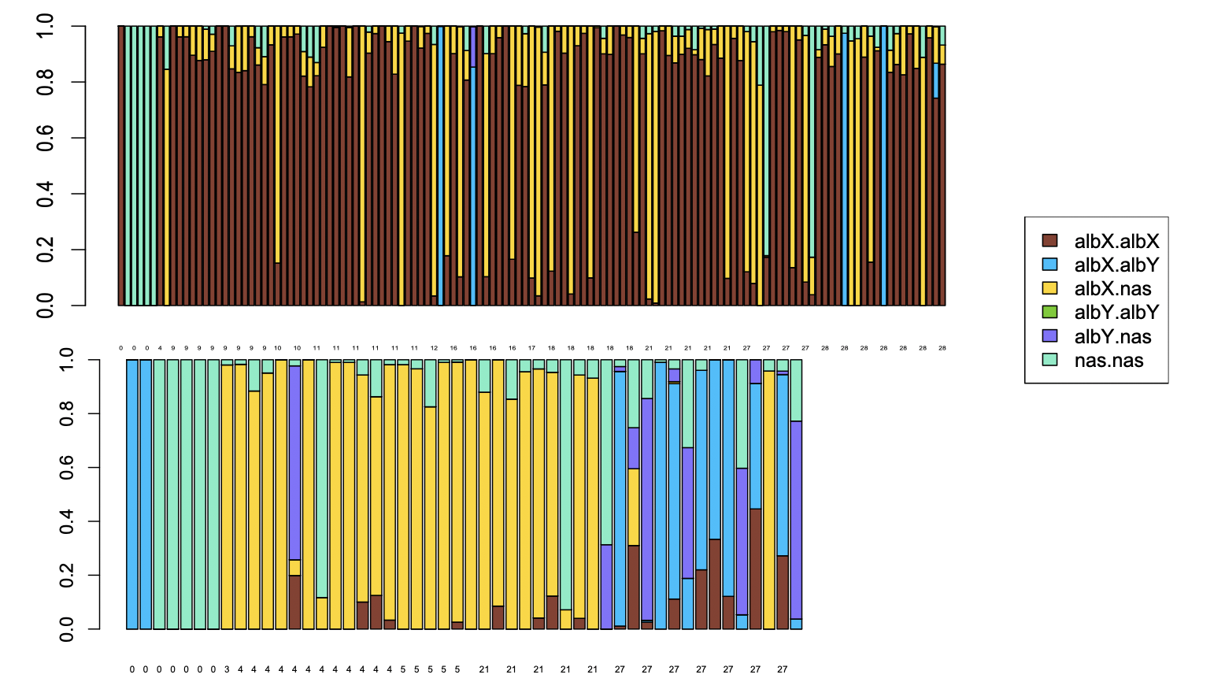

**Figure 2 Muller CD haplotypes individuals**

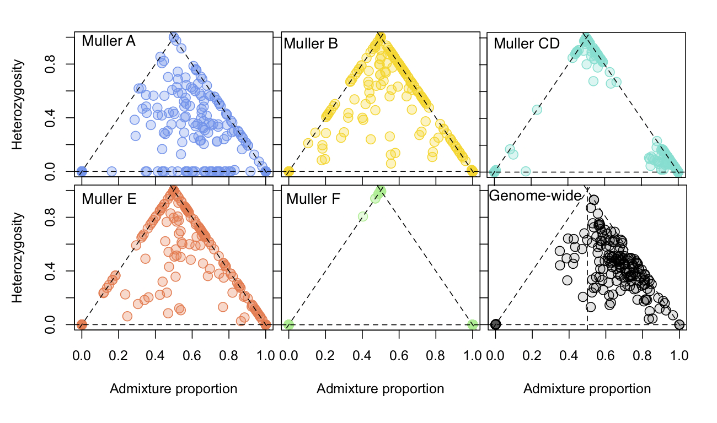

**Figure 3** Triangle plot **Chromosome-specific Heterozygosity and ancestry index**.

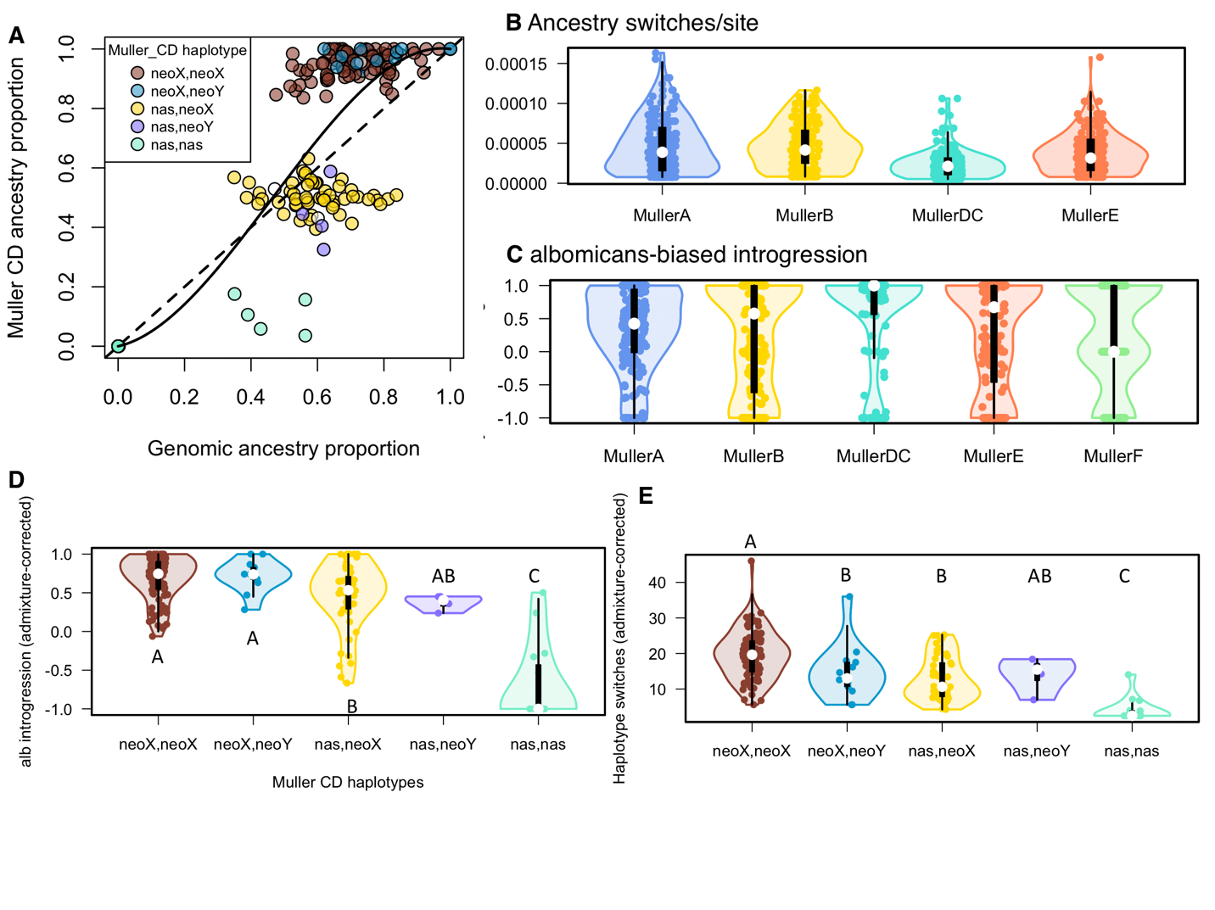

**Figure 4 Neo-sex chromosome inheritance-driven albomicans-biased introgression** **A**, Muller CD harbors barrier effect and alb-biased introgression than the rest of the genome. Muller CD demonstrates less ancestry turnovers per site (**B**) and greater albomimcans-biased introgression (corrected for admixture, **C**) than Muller A, B, and E. **D**, There was greater alb introgression (controlled for admixture, **D**) and ancestry switches (controlled for admixture, **E**) in individuals with (neoX, neoX) and (neoX, neoY) haplotypes. **D**-**E**, The letters “A-C” on the plots delineate significantly different (*p* < 0.05) groups.



**Figure 5 Cross-generational barrier effects and ancestry advantage at genetic clusters** The plots demonstrate estimates (surrounded by 95% CI) of alpha and/or beta genomic cline parameters across K-means genetic clusters in the genome in later generations (21, 27, and 28) of hybrids. A genetic cluster in Muller CD demonstrate significantly positive beta values (right panel, yellow) consistently across generations (21 to 28), implying that is cluster is a barrier to introgression. A different set of genetic clusters (largely within Muller E) turn out to show significant alb-biased introgression (left panel yellow dots, positive alpha), suggesting potential advantage of alb ancestry at these regions. In contrast, a cluster in Muller B consistently showed significant nas-biased introgression (left panel turquoise dots, negative alpha), indicating nas advantage at this genetic cluster.

**Figure 6** **LD between muller CD and other muller element**

A, muller CD and F, early

B, muller CD and A, B, E, F, late

C. network of muller A-F significant r

**Discussion**

With generations of hybrid swarms, we have identified signatures of barriers to gene flow and the elevated LD among the barriers over generations of admixture which is expected to break down ancestry blocks under neutral scenario. The greater LD among barrier genetic cluster relative to the rest of the genome suggests selection keeping the barriers together. In addition, the

elevation of the LD among barrier clusters over generations of admixture further revealed the role of selection.

Asymmetrical introgression of parental background (Matute et al. 2020). We observed similar pattern, but not as extreme.

Low recombination regions are associated with barriers

**Reference**

Campbell, C. R., J. W. Poelstra, and A. D. Yoder. 2018. What is Speciation Genomics? The roles of ecology, gene flow, and genomic architecture in the formation of species. Biol. J. Linn. Soc. 124:561–583.

Darwin, C. 1859. On the Origin of the Species.

Gompert, Z., and C. A. Buerkle. 2011. Bayesian estimation of genomic clines. Mol. Ecol. 20:2111–2127.

Gompert, Z., and C. A. Buerkle. 2016. What, if anything, are hybrids: enduring truths and challenges associated with population structure and gene flow. Evol. Appl. 9.

Li, H. 2010. Aligning new-sequencing reads by BWA BWA : Burrows-Wheeler Aligner. Slides, doi: 10.1002/pssa.200673542.

Matute, D. R., A. A. Comeault, E. Earley, A. Serrato-Capuchina, D. Peede, A. Monroy-Eklund, W. Huang, C. D. Jones, T. F. C. Mackay, and J. A. Coyne. 2020. Rapid and predictable evolution of admixed populations between two Drosophila species pairs. Genetics 214:211–230.

**Supplementary**



**Figure S1** Ancestry haplotypes, each column is a SNP, each row is an individual.



**Figure S2** ancestry haplotypes after imputation, each column is a SNP, each row is an individual. The generation number is on the right side.

**Table S1**

|  |  |  |  |  |  |
| --- | --- | --- | --- | --- | --- |
|  | **Muller A** | **Muller B** | **Muller CD** | **Muller E** | **Muller F** |
| Ancestry-informative sites | 8928 | 12922 | 29142 | 11508 | 1532 |
| K-means clusters | 43 | 89 | 73 | 42 | 3 |